Mrs.Verraneault
n.verraneault@stephen.org

K-2 Physical Education
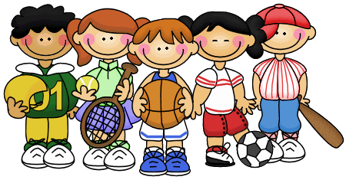

Course Objective
The primary goal of physical education is to assist students in the development of skills and knowledge of human movement that will help develop a life of physical activity with a focus on cooperative play, sportsmanship, and leadership skills in a safe environment.

Attire
Shoes: All students must wear athletic shoes to class. One point will be deducted from his/her grade if this requirement is not met.
Shorts: Girls are encouraged to wear shorts to class and jumpers can be left in the classroom. Points will not be deducted from their grade if they wear their jumpers to class. Skorts are also acceptable.

Safety
Safety will always be the most important aspect of any PE class. The Boys Town skills will be used to help develop positive attitudes and actions during class.

Curriculum
The student will be introduced to a variety of movements and sports experiences with guided instruction from the teacher. Assessment will be teacher observation.

Movement Concepts | Skill Themes
- Locomotor Skills  - Jog/Skip/Gallop/Hop/Jump  - Nonlocomotor Skills  - Stretching/Bending/Twisting  - Spatial Awareness  - Personal & General  - Traveling in small & large space  - Directions/Levels/Pathways  - Coordination  - Eye-Hand/Eye-Foot | - Traveling & Dodging  - Dribbling  - Tossing/Throwing/Catching  - Kicking  - Jumping/Landing/Weight Transfer  - Volleying/Striking  - Tumbling  - Specific Sports Skills
Grading
Each class is worth 8 points:
- points---Participation
- points---Cooperation/sportsmanship/safety
- point----Wearing proper tennis shoes
**If student is absent, no make-up work is required.

